

**SHAID SMARAK COLLEGE**

Kirtipur-10, Kathmandu



*Assignment No. 4 of C -Programming*

**Submitted by:- Submitted to:-**

2nd Semester BCA **Himal Raj Gentil**

**Amir Maharjan**

# C - programming

Assignment No. 4

1. While Statement:

Program for generating N natural numbers.

**Program**

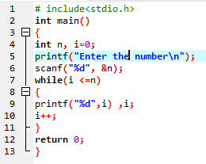

**Output**

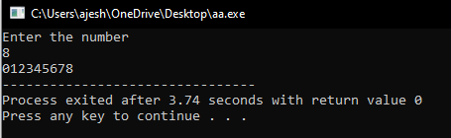

1. Program to Illustrate do...while loop.

**Program**

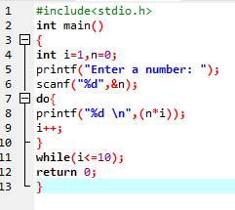

**Output**

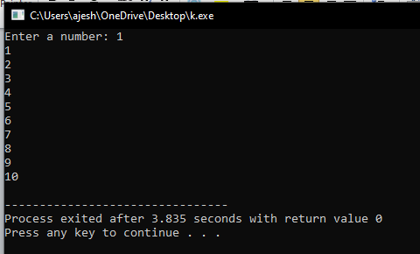

3. Break Statement:

Program to calculate average marks

**Program**

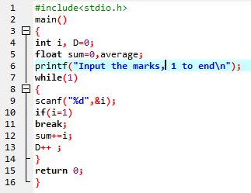

**Output**

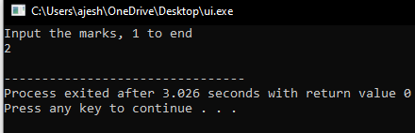

1. Continue Statement:

Program to find sum of all positive numbers

**Program**

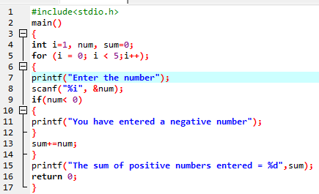

**Output**

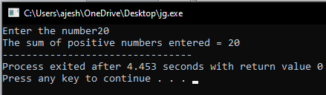

1. For Loop:

Program to find sum of first 15 positive even numbers and sum of their squares.

**Program**

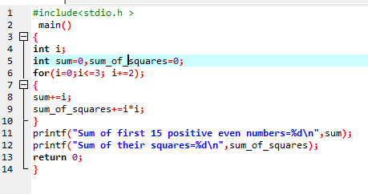

**Output**

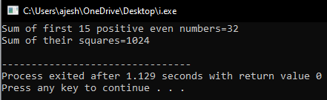

The end